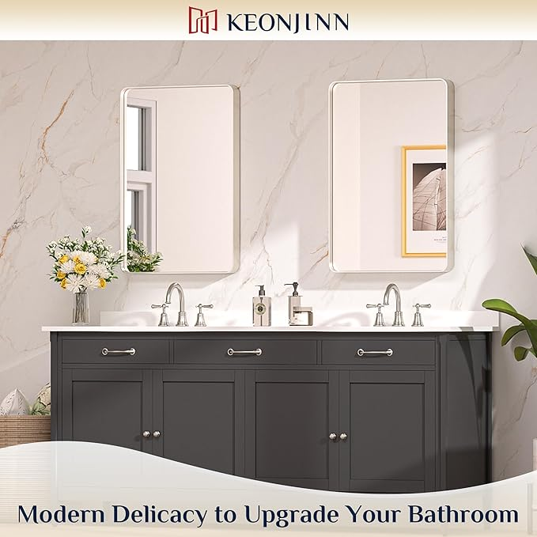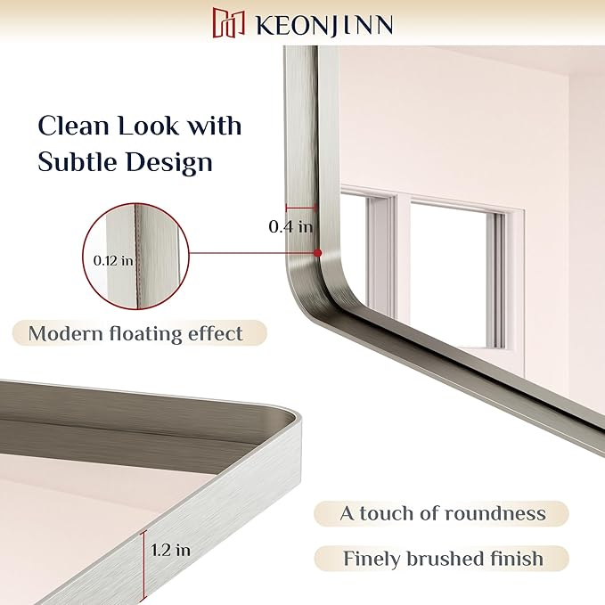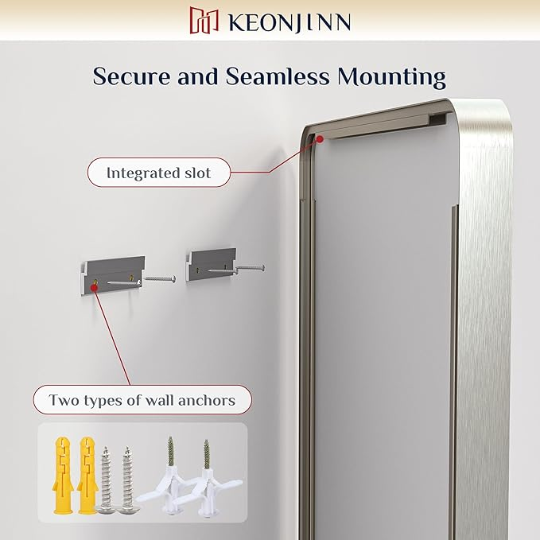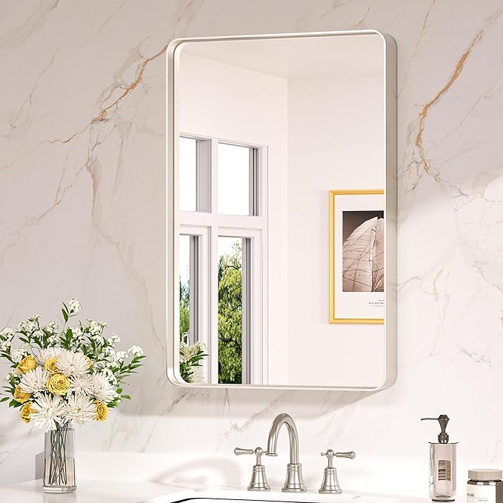

Keonjinn 20 x 30 Inch Brushed Nickel Bathroom Mirrors for Over Sink, Rounded Rectangle Silver Bathroom Vanity Mirror, Farmhouse Mirror for Wall, HD Tempered Glass, Seamless Aluminum Alloy Frame Mirror

**PRODUCT DESCRIPTION:**

|  |  |  |  |  |  |  |  |  |  |  |  |
| --- | --- | --- | --- | --- | --- | --- | --- | --- | --- | --- | --- |
| |  |  | | --- | --- | | **Brand** | Keonjinn | | **Room Type** | Bathroom, Bedroom, Living Room, Hallway, Dining Room | | **Shape** | Rectangular | | **Product Dimensions** | 30"L x 20"W | | **Frame Material** | Aluminum |   **About this item**   * 【Modern Elegance Meets Versatile Styles】 Embrace the modern sophistication of Keonjinn Rounded Metal Frame Mirror. With a clean rounded rectangular shape and subtle details such as a floating effect, the wall mirror is meticulously designed to add a delicate touch to any decor in your bathroom, bedroom, living room, fireplace or entryway. * 【Sturdy Frame with Color Options】Crafted with enduring aluminum alloy, this vanity mirror's sturdy frame remains moisture-proof, rust-resistant, and non-deforming over time, providing a reliable addition to your bathroom. Choose from four elegant color options: Matte White and Matte Black, both featuring a fine granular finish; Matte Silver with a smooth matte surface; Brushed Gold and Brushed Nickel, both with a sleek, brushed texture. Each color brings its unique charm, to match any décor. * 【Strong Mirror with Shatter-proof Assurance】Experience crystal-clear and distortion-free reflections with our brushed nickel bathroom mirror's 4mm thick tempered glass. Reinforced with a shatter-proof film, it ensures both safety and durability, allowing you to focus on your daily grooming routine without worry. * 【Enhanced Packaging for Safe Arrival】 Our packaging is designed to withstand the rigors of transit and protect your wall mirror. With four layers of protection and enhanced EVA corner guards, your framed mirror will arrive securely. Experience peace of mind from the moment you unbox it. * 【Seamless Installation with Ease】 The integrated slot design of our mirror two types of wall anchors included ensures a secure and hassle-free mounting. Whether vertically or horizontally hung, our brushed nickel mirror seamlessly integrates into your space, elevating your bathroom with ease. |  |